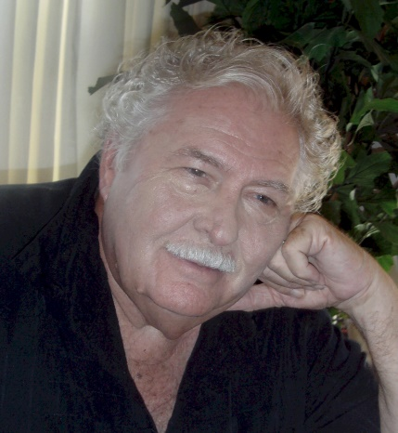

DL HAVLIN

Presents

FEBRUARY 24, 11:00 AM
Florida’s Contribution to WW II &  World War II’s Contribution to Florida  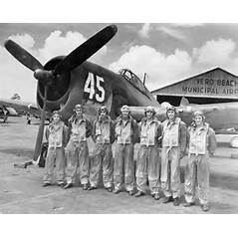  Kings Gate  24000 Rampart Boulevard  Port Charlotte, FL 33980  941.764.1282 | Today Florida is considered one of the best places in the US to live. It wasn’t that way prior to WWII. Florida was the most backward state East of the Mississippi in 1940. The war effort changed all that. Learn how WWII became the “father” of modern Florida and the great contributions Florida made to winning the war. See author DL Havlin’s power-point presentation.

